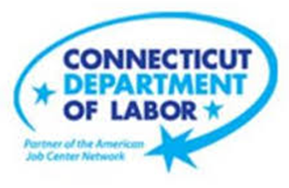

**NEW WEEKLY JOB POSTINGS FROM   
HELP WANTED ONLINE  
Office of Research**

**Week Ending April 23rd, 2022: Statewide New Job Ads Rebound After One Week Dip**WETHERSFIELD, April 29th, 2022 – During the week ending April 23rd, there were 9,251 new postings, up 2,528 new ads or +38% over the week. More than half of this increase occurred in Pro., Sci., & Tech. Services (+678 new ads), Finance & Insurances (+445 new ads), and Retail Trade (+311 new ads). The employers with the most new ads include PricewaterhouseCoopers (689 new ads), Capital One (535 new ads), and Hartford Healthcare (122 new ads). This new ad increase follows a one-week dip during the week ending April 16th to 6,837 new ads. The other three weeks in April 2022 ranged between 8,488-9,251 new ads. April 2021 had a similar one-week dip. Ads reached an April 2021 low of 4,189 during the week ending April 10th, 2021 and ranged between 6,187-6,959 during the other three weeks. These dips may relate to an ad posting slowdown around major religious holidays that occur in April. The four weeks ending in April 2022 averaged 8,426 new ads and the past three months are among the top four highest monthly averages shown in the graph below.  
  
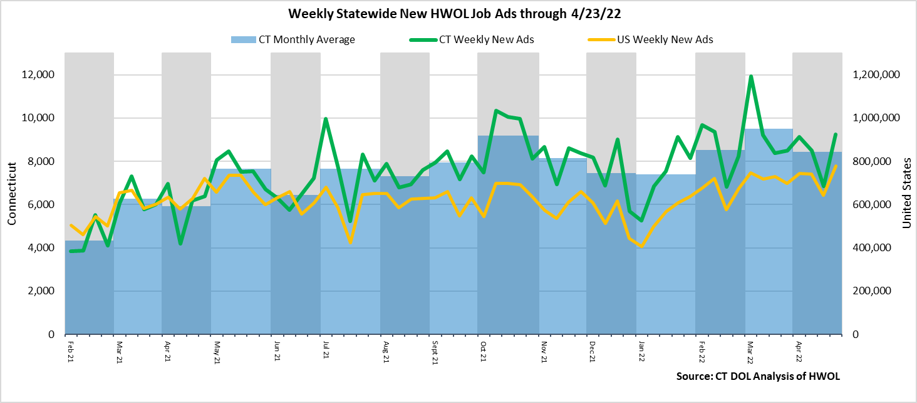  
**Industries** with the most new postings include Health Care & Social Assistance, Finance & Insurance, and   
Professional, Scientific, & Technical Services.

**Occupations** with the most new postings include Registered Nurses, Retail Salespersons, and Wholesale & Manufacturing Sales Representatives.

**Employers** with the most new postings include PricewaterhouseCoopers, Capital One, and Hartford Healthcare.

**The three industries with the most new job postings were:**

* **Health Care & Social Assistance** (1,339 new postings, -1% over the week)
* **Finance & Insurance** (1,302 new postings, +52% over the week)
* **Pro., Sci., & Tech. Services** (1,156 new postings, +142% over the week)

   
 During the week ending April 23rd, the total ad increase of 2,528 new ads is the net result of change within 14 increasing, 5 decreasing, and two unchanged industries. The 14 increasing industries grew by a combined 2,561 new ads. 44 percent of that combined increase occurred in Pro., Sci., & Tech. Services (+678 new ads) and Finance & Insurance (+445 new ads). The five decreasing industries fell by 12 new ads or less over the week. A third of industries had increases of over 50%, the largest being Pro., Sci., & Tech. Services (+142%) and Other Services (+101%).   
Over four weeks, new ads were up 733 postings. This top line increase overlays a combined 1,783 increase in 10 increasing industries and a combined 1,050 decrease at 11 industries. The largest of each over four weeks was +663 within Pro., Sci., & Tech. Services and -656 within Health Care & Social Assistance.   
  
 For more information on total job ads by industry for Connecticut and its labor market areas, see the monthly report available here: <https://www1.ctdol.state.ct.us/lmi/hwol.asp>

**New Job Postings by Occupation** 

**The occupations with the most new postings were:**

* Registered Nurses (311 new postings, +3% over the week)
* Retail Salespersons (294 new postings, +100% over the week)
* Sales Representatives, Wholesale & Manuf. (253 new ads, +104% over the week)

**Employers with the Most New Job Postings**

Employers with the most new job postings during the week were mostly in Healthcare, Finance & Insurance, and Retail Trade. The 25 employers shown above account for 25 percent of all new ads. Among the top 25 employers, 22 had over the week ad increases and 3 had decreases. The largest top 25 employer over the week was PricewaterhouseCoopers (+683 new ads) and the largest decreasing employer was Yale-New Haven Health System (-66 new ads). Over four weeks, 17 of 25 employers shown above had increases, one was unchanged, and 7 had decreases. The largest of each was PricewaterhouseCoopers (+682 new ads) and Hartford Healthcare (-279 new ads).

**What is HWOL?**The **Conference Board Help Wanted Online**® Data Series (HWOL) measures the number of new, first-time Online job postings and jobs reposted from the previous month for over 16,000 Internet job boards, corporate boards and smaller job sites that serve niche markets and smaller geographic areas. To view more HWOL data, go to: <https://www1.ctdol.state.ct.us/lmi/hwol.asp>